Evrim Ciftci 200539682

Navjot Singh 200536421

Java assignment 2

Level 1 output

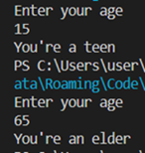

Level 1 code

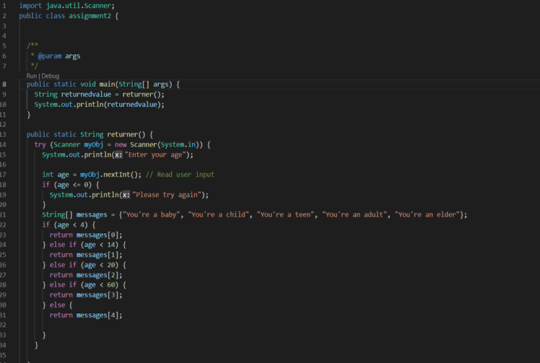

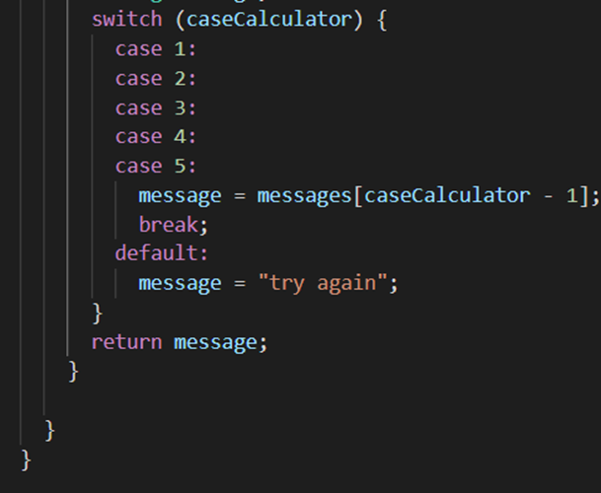

Level 2 output

Level 3 output

